Ratio-Based Estimation

📌 What is Ratio-Based Estimation?
# Source: AI Source: Provided by: [Data Path: Persons Table -> ID Column: 1, Name_En Column: Motasem Essam] -> From: [ChatGPT] on [8/24/2025]
It is an estimation technique where the testing effort is calculated as a fixed ratio (percentage) of another related project activity, usually development effort or project size.
👉 In simple words:
“Testing = X% of development.”

🗂️ How It Works
# Source: AI Source: Provided by: [Data Path: Persons Table -> ID Column: 1, Name_En Column: Motasem Essam] -> From: [ChatGPT] on [8/24/2025]
- Look at past projects (historical data).
- Find the ratio between development and testing effort (e.g., 40% of dev time).
- Apply that ratio to the new project.

📊 Example of Ratio-Based Estimation
# Source: AI Source: Provided by: [Data Path: Persons Table -> ID Column: 1, Name_En Column: Motasem Essam] -> From: [ChatGPT] on [8/24/2025]
- From past projects: Testing usually takes 30% of development effort.
- Current project: Development effort is estimated at 1,000 hours.
- Testing Effort = 30% × 1,000 = 300 hours.
✅ So, testing effort = 300 hours

✅ Advantages
# Source: AI Source: Provided by: [Data Path: Persons Table -> ID Column: 1, Name_En Column: Motasem Essam] -> From: [ChatGPT] on [8/24/2025]
- Very quick and simple.
- Works well if past projects are similar in domain/technology.
- Useful in early project stages (when details are not clear).

⚠️ Disadvantages
# Source: AI Source: Provided by: [Data Path: Persons Table -> ID Column: 1, Name_En Column: Motasem Essam] -> From: [ChatGPT] on [8/24/2025]
- Accuracy depends on good historical data.
- May overestimate or underestimate if the project has different complexity, risks, or quality goals.
- Doesn’t account for special testing types (e.g., security, performance).

Is Ratio-Based Estimation IS SAME Matrix based technique

📌 Ratio-Based Estimation
# Source: AI Source: Provided by: [Data Path: Persons Table -> ID Column: 1, Name_En Column: Motasem Essam] -> From: [ChatGPT] on [8/24/2025]
- Uses a fixed percentage/ratio to estimate testing effort based on another activity (like development effort, LOC, or function points).
- Very simple formula approach.
Example:
If past data shows that testing = 30% of development effort, and development is estimated at 1,000 hours → testing = 300 hours.

📌 Matrix-Based Estimation
# Source: AI Source: Provided by: [Data Path: Persons Table -> ID Column: 1, Name_En Column: Motasem Essam] -> From: [ChatGPT] on [8/24/2025]
- Uses a matrix (table) of predefined values for effort or cost, based on parameters such as complexity, risk level, size, or requirement type.
- It’s more detailed and structured than ratio-based.
Example Matrix:
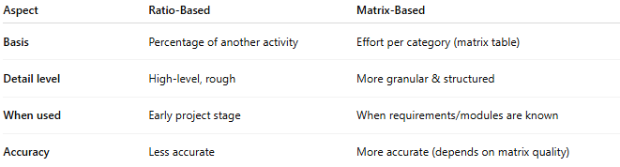
Module Type | Size (LOC / FP) | Complexity | Estimated Test Effort
Login | Small (200 LOC) | Low | 10 hrs
Payment | Medium (500 LOC) | Medium | 40 hrs
Security | Large (1000 LOC) | High | 100 hrs
👉 You add up effort across modules to get the total test estimate.

🔑 Key Difference
# Source: AI Source: Provided by: [Data Path: Persons Table -> ID Column: 1, Name_En Column: Motasem Essam] -> From: [ChatGPT] on [8/24/2025]
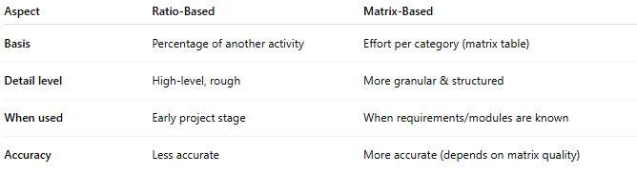
Aspect | Ratio-Based | Matrix-Based
Basis | Percentage of another activity | Effort per category (matrix table)
Detail level | High-level, rough | More granular & structured
When used | Early project stage | When requirements/modules are known
Accuracy | Less accurate | More accurate (depends on matrix quality)

✅ So, ratio-based estimation is simpler, while matrix-based estimation is more detailed.
You can say: Ratio-based = quick % approach, Matrix-based = structured table approach.

Real-world example
# Source: AI Source: Provided by: [Data Path: Persons Table -> ID Column: 1, Name_En Column: Motasem Essam] -> From: [ChatGPT] on [8/24/2025]
Here’s a side-by-side real-world example using the same project estimated with Ratio-Based Estimation vs Matrix-Based Technique:

✅ Scenario
# Source: AI Source: Provided by: [Data Path: Persons Table -> ID Column: 1, Name_En Column: Motasem Essam] -> From: [ChatGPT] on [8/24/2025]
- Project: An e-commerce website
- Modules: Login, Product Catalog, Payment, Reports
- Development effort: 1,000 hrs
- Testing ratios and complexity assumptions given below.

1. Ratio-Based Estimation
# Source: AI Source: Provided by: [Data Path: Persons Table -> ID Column: 1, Name_En Column: Motasem Essam] -> From: [ChatGPT] on [8/24/2025]
Uses historical ratio Dev:Test = 1:0.4.
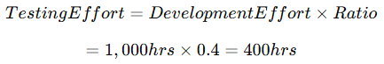
TestingEffort=DevelopmentEffort×RatioTesting Effort = Development Effort × Ratio =1,000hrs×0.4=400hrs= 1,000 hrs × 0.4 = 400 hrs
✅ Result:
Total Testing = 400 hrs

2. Matrix-Based Technique
# Source: AI Source: Provided by: [Data Path: Persons Table -> ID Column: 1, Name_En Column: Motasem Essam] -> From: [ChatGPT] on [8/24/2025]
Assign effort per module based on complexity level:
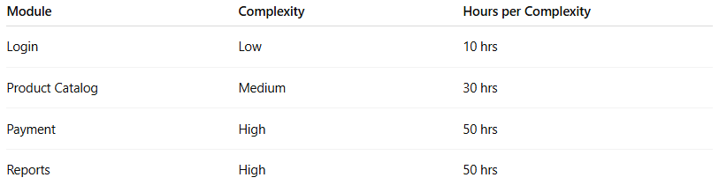
Module | Complexity | Hours per Complexity
Login | Low | 10 hrs
Product Catalog | Medium | 30 hrs
Payment | High | 50 hrs
Reports | High | 50 hrs

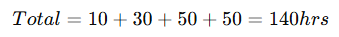
Total=10+30+50+50=140hrsTotal = 10 + 30 + 50 + 50 = 140 hrs
✅ Result:
Total Testing = 140 hrs

Difference
# Source: AI Source: Provided by: [Data Path: Persons Table -> ID Column: 1, Name_En Column: Motasem Essam] -> From: [ChatGPT] on [8/24/2025]
- Ratio-Based assumes overall effort based on past ratios → 400 hrs
- Matrix-Based breaks down per feature complexity → 140 hrs
➡ Ratio method can overestimate if modules are simple, while Matrix method gives granular accuracy but requires detailed analysis.

🔑 Comparison with Extrapolation
# Source: AI Source: Provided by: [Data Path: Persons Table -> ID Column: 1, Name_En Column: Motasem Essam] -> From: [ChatGPT] on [8/24/2025]
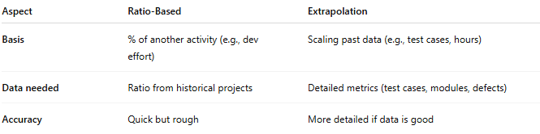
Aspect | Ratio-Based | Extrapolation
Basis | % of another activity (e.g., dev effort) | Scaling past data (e.g., test cases, hours)
Data needed | Ratio from historical projects | Detailed metrics (test cases, modules, defects)
Accuracy | Quick but rough | More detailed if data is good

👉 So, Ratio-Based Estimation = Testing effort as a percentage of development effort (or project size).

